

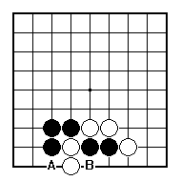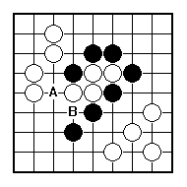
Is it worth it for White to try to get out of this atari?

Is it worth it for White to try to get out of this atari?

Is it worth it for White to try to get out of this atari?

Which is the better way for Black to give atari – A or B?

Which is the better way for Black to give atari – A or B?

NAME:
Is it worth it for White to try to get out of this atari?

BRITISH GO ASSOCIATION CERTIFICATE LEVEL 2 - SHEET 4

BASIC ATARIS

